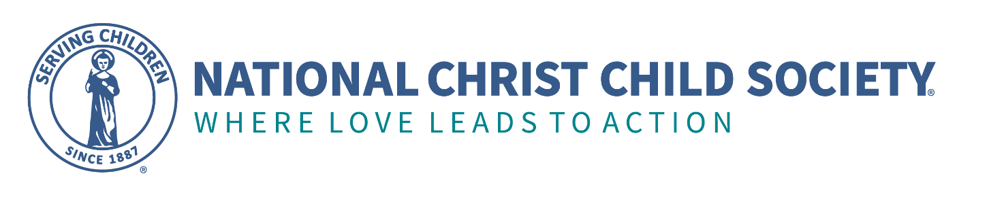
For Immediate Release: November 19, 2021
Contact: Anne Kelley, 206-949-2944 and christchildmontereybay@outlook.com

Christ Child Society of Monterey Bay Partners with Natividad and the Salinas Fire Department to Provide Car Seats to Families with Low Incomes
[SALINAS, Calif.] — The Christ Child Society of Monterey Bay, in partnership with the Natividad Medical Center and Salinas Fire Department, have committed to providing 60 families with infants born at Natividad in 2022 with Graco 4Ever® car seats.

The new Christ Child program fills a recent gap in third-party funding for car seats at Natividad and doubles the impact of the previous program. Natividad’s Women and Children’s Services plans to select families to receive the car seats based on financial need and to facilitate appointments with the Salinas Fire Department at Station No. 1.

Bilingual Fire Department personnel will train the families on how to use and install the car seats, which are are designed to transition from a rear-facing harness to a forward-facing harness and two types of booster seats to keep children safe from four to 120 pounds, or until they no longer need the protection of a car or booster seat.

The Christ Child Society of Monterey Bay will purchase the car seats and deliver them to Fire Station No. 1 monthly. Families who receive the car seats will also receive one of the 120 bundles of baby essentials that the Christ Child Society provides to Natividad each year. These baby bundles, delivered in diaper bags, contain clothing, blankets, socks, diapers, wipes and baby board books, in addition to teddy bears, blankets, quilts and caps handmade with love by Christ Child members.

“When we learned this year that the corporate funding had lapsed for the car seats, we decided to fill the gap in 2022 and double the number to 60. We believe that child health, security and safety are critical, so we decided to provide the Graco 4Ever car seat so that these financially stressed families would not need to replace or upgrade it over the 7 or 8 years that most children need car seat protection,” said Christ Child Society of Monterey Bay President Anne Kelley.

According to April Ritchie, Director of Women’s and Children’s Services at Natividad, “We appreciate the Christ Child Society of Monterey Bay and its consistent commitment to babies at Natividad over the last four years.
The families who receive the Christ Child Society bundles are working hard to make ends meet, and we are delighted that this partnership helps families protect their children and give them a healthy start. Thanks to this new program, families who qualify receive a top-of-the-line car seat. And thanks to the Salinas Fire Department, families can learn how to use and install their car seats correctly — studies show 70 to 90 percent are installed incorrectly.”

Fire Chief Michele Vaughn is supportive of this program. “The City of Salinas and Fire Department are excited

----- MORE -----

to be able to promote safety for infants and their families by providing short-term storage as well as training and delivery of the car seats funded by the Christ Child Society of Monterey Bay in coordination with Natividad. We are dedicated to serving this community, and this is a fantastic opportunity to make sure families are prepared to transport their babies safely, as infants and as they grow.”

The Christ Child Society has selected Costco Wholesale as the most cost-effective provider of the Graco 4Ever car seat in our area at this time, and will purchase the first 30 car seats from the Salinas Warehouse this month. Costco Wholesale Salinas agreed to make a cash donation to defray costs. The store’s general manager, Fernando Favela, said, “We are happy to support this great joint endeavor by the Christ Child Society of the Monterey Bay with Natividad and the Salinas Fire Department. Costco is focused on quality and value, and the Graco 4Ever is one of our best-selling car seats, so we know that the families who receive them will find them to be useful for many years.”

The Christ Child Society welcomes financial donations to support the new car seat program and its ongoing bundles and preschool literacy programs. Donate online at www.christchildmontereybay.org. To fund the program beyond 2022, the Christ Child Society is asking for community support at its annual fundraising event next month: Shower of Love | CCS Monterey Bay (christchildmontereybay.org) on Saturday, December 4, from 10 a.m. to noon at the Carmel Mission’s MacMahon Center, 3080 Rio Road, Carmel, CA.

About the Christ Child Society of Monterey Bay www.christchildmontereybay.org
The Christ Child Society of Monterey Bay is a California non-profit corporation and federal 501(c)(3) dedicated
to serving infants and preschool-aged children in Monterey County since 2016. A chapter of the National Christ Child Society (www.nationalchristchild.org), the Christ Child Society of Monterey Bay assists local children and families through personal service and basic needs support, delivered with love and respect. We are moved to action by the words of our founder, Mary Virginia Merrick, who said: “Nothing is ever too much to do for a child.”

About Natividad Medical Center www.natividad.com
Natividad is a hospital and Level II Trauma Center providing compassionate high-quality health care to everyone, regardless of their ability to pay or immigration status. Owned and operated by the County of Monterey, Natividad is the Central Coast’s only teaching hospital. Natividad offers a wide range of inpatient, outpatient, emergency, diagnostic and specialty medical care for adults and children. The hospital has made the Cal Hospital Compare Maternity Honor Roll for the past five years and is widely known for its high-quality maternity care. For more information about Women’s and Children Services at Natividad, contact Hilary Fish, Director of Marketing and Community Relations at Fish at FishH@natividad.com or 831-783-2693.

About the Salinas Fire Department Fire Department | City of Salinas

For more information contact Chief Michele Vaughn at michelev@ci.salinas.ca.us or 831-758-7470.

About Costco Wholesale Salinas, CA Warehouse | Costco

Costco is a membership warehouse club, dedicated to bringing its members the best possible prices on quality brand-name merchandise. With hundreds of locations worldwide, including Costco Wholesale #472 Salinas, Costco provides a wide selection of merchandise, plus the convenience of specialty departments and exclusive member services, all designed to make its customers’ shopping experience a pleasurable one. For more information contact Fernando Favela at w472mgr@Costco.com or 831-424-4242.

